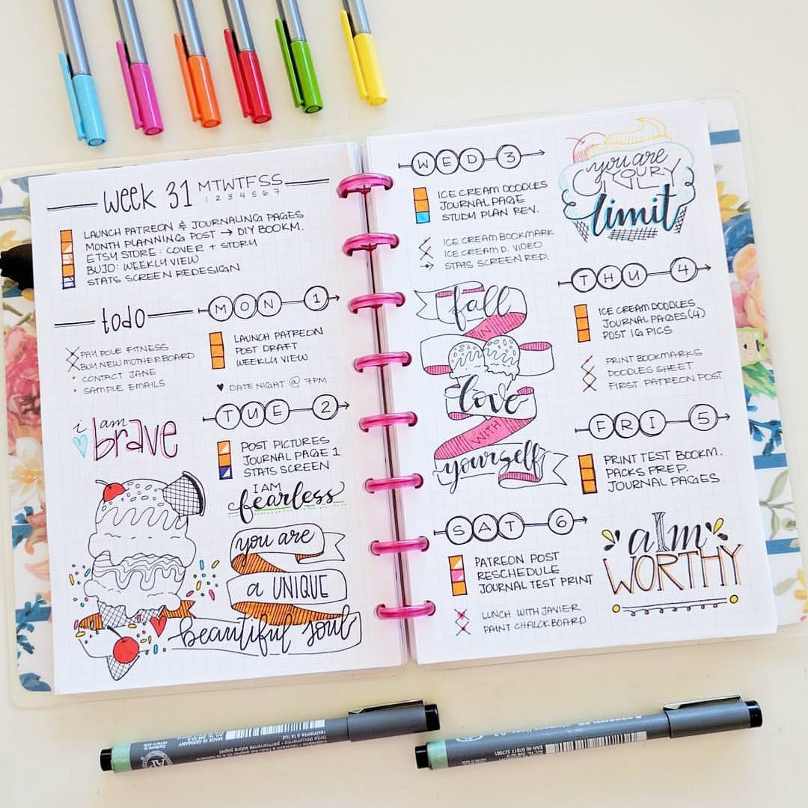

BULLET JOURNAL

RYANA CALENDARS is selling wonderful BULLET journals !at reasonable prices. It contains beautiful and designable covers!

**RS 880**